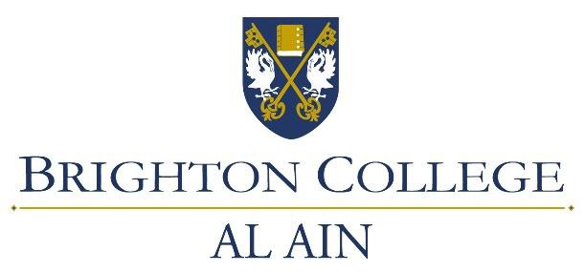

Job Description:
Personal Assistant to the Head Master

Role Outline
This is a senior position within the support team at Brighton College Al Ain. The role centres on providing support to the Head Master and brings with it a requirement of efficiency, organizational skills and the ability to prioritise workloads. Confidentiality and flexibility is essential.

Main Duties

- Manage the Head Master’s diary & screening calls
- Make appointments for staff, parents and external visitors
- Greet, assist and/or direct all pupils, parents, staff and general visitors around the College
- Attending and producing minutes for CLT, OSH and Covid Task Force meetings as required
- Recruitment of staff (academic and business) – advertising, first point of contact, collating applications and first sift to ensure basic criteria is met, arranging interviews and follow up letters as required
- Composing and distribution of a wide range of letters and emails to staff, parents and carers
- Familiarisation with Adek correspondence and procedures, forward to staff as necessary.
- Liaise with Finance and Procurement to resolve queries.
- Assist Admissions with letters and bursary applications
- Main point of contact for any Compliance checks by outside agencies.
- Preparation of documentation for Inspections and Compliance.
- Assisting Exam Officer – accepting exam materials, safe storage, dispatch of exam scripts, certification checking and distribution.
- Keep up to date with OSH procedures and requirements, first aiders, evacuation procedures, evacuation lists, notice boards

- Covid Compliance, daily checks, follow up on suspected cases & contact tracing
- Plan schedules for BCUK visitors
- Electronic & Physical file maintenance – confidential data
- Assist HR with confidential letters (salary & immigration letters), staff induction and references, and admin support as required.
- Organise school functions – graduation ceremonies, Iftar, school photographs.
- Book conferences, travel arrangements as required, flights, hotels, cars.
- Arranging catering for meetings and events.
- Replenishing refreshments in the staff common rooms.
- Liaising with internal contractors with any facilities issues.
- Any ad hoc projects/reports/ investigations as requested

Key Skills

- Excellent English (written & spoken) with a sharp eye for detail
- Team Player
- Able to build effective relationships across the college with both academic and support staff
- Self-disciplined and with excellent time management skills able to work to deadlines
- Strong working knowledge of Microsoft office (word, excel, PowerPoint), Google suite, Isams

Personal Attributes

- Professional & polite with a welcoming smile
- Excellent communication and customer service skills
- Flexible and conscientious
- Discreet & sensitive when needed
- High degree of confidentiality

